**Course: Introduction to Data Science (DS2006) - Laboratory 05**

**Student:**

Over the last few classes, we have seen variables, how to print things to the screen, how to get input from the user, how to make choices using selection structures (if-elif-else), how to make loops (using for and while), how to use lists and how to save files. Today we have some coding tasks that will need you to use all of this knowledge together.

* **Task 1**: Look at the code shown in Figure 1. What is the purpose of this code?

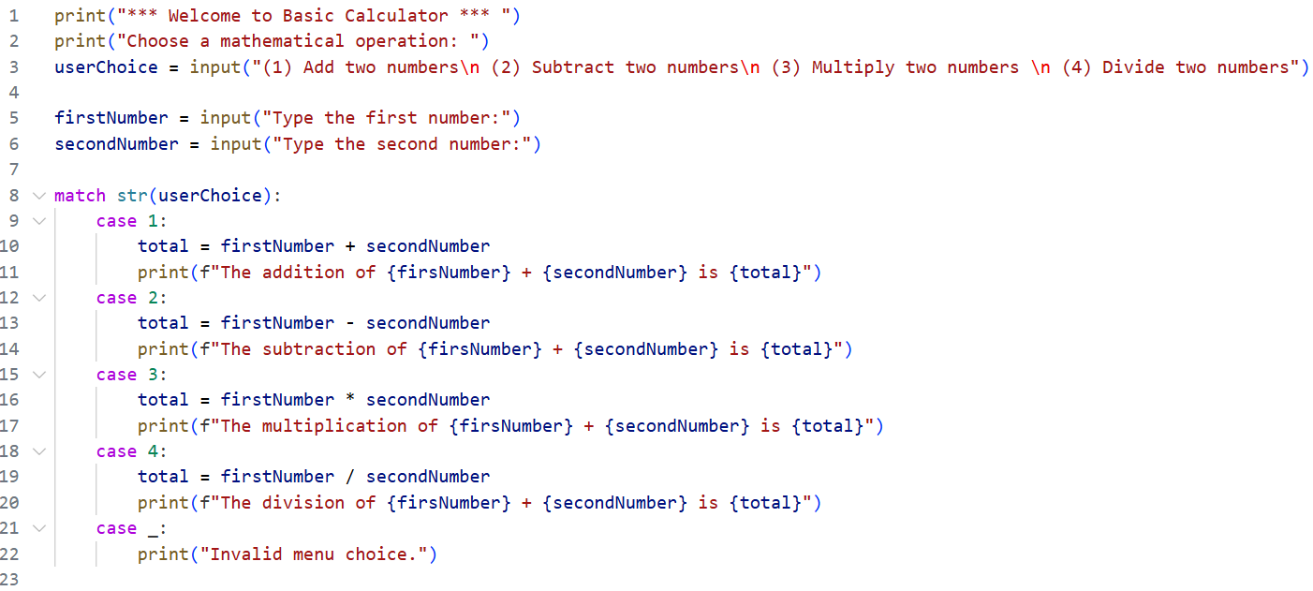

Figure 1 - Problematic Code Snippet for a basic calculator.

* **Task 2**: Implement this code in a file named bad_calculator.py . As this name suggests, there is at least one problem with this code. Try the code out and identify all the problems you can with it.
* **Task 3**: Create a file named better_calculator.py where you fix the problems you identified in task 3.
* **Task 4**: Refactor your better_calculator.py to have functions to perform the addition, subtraction, multiplication and division of two numbers passed as parameters. That way the code can be used by other programs in the future.
* **Task 5**: Add one more mathematical operation of your choice to better_calculator.py.
* **Task 6**: Have you ever heard of the popular game “Jankenpo (じゃんけんぽん)” also known as “Rock-paper-scisors”? It is a two player game, where the player has to choose between using “rock”, "scissors" or “paper”. The rules are simple:
  + Rock beats Scissors
  + Scissors beats Paper
  + Paper beats Rock

The objective of this task is that you implement the code in a file named [**jankenpo.py**](http://jankenpo.py) to allow for a human player to play against a machine. **Hint:** One way you can randomize the action chosen by the computer is to have a dice.rollD3() function, and assign one action to each possible value.

* **Task 7**: Jankenpo is a really popular game where people add new variations (new hand movements with new names) all the time. Create your own variation by giving it a name and specific rules. Describe the name here and its specific rules. Implement this version in a file named [**myjankenpo.py**](http://jankenpo.py)